**Brooklyn torah gazette**

**For parshas eikev 5782**

Volume 6, Issue 47 (Whole Number 302) 23 Menachem Av 5782/ Aug, 20, 2022

**Chicken Soup for the Mind**

**By**[**Jack Botwinik**](https://aish.com/authors/48867817?aut_id=6687)

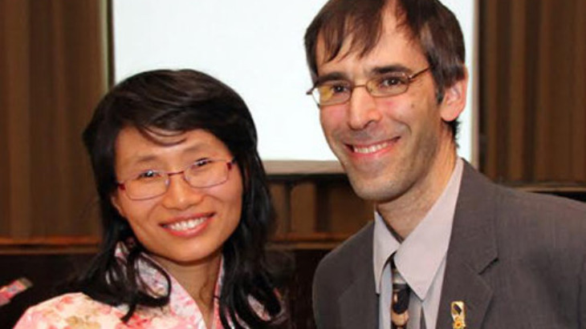

*A Chinese girl forced me to confront what it means to be Jewish.*

“What are we waiting for?" my Chinese girlfriend asked, somewhat confused, as we sat facing each other in the privacy of my apartment. For weeks we’d been talking about the prospect of getting married.

I held back. I was not supposed to marry a Gentile, I thought. It would be a betrayal of my family, my ancestors, my tradition. Yet it would sound racist if I told her that.

Then I realized: It would [sound racist](http://www.aish.com/jw/s/48883852.html) to me as well.

I was raised with a lox-and-bagels Judaism, replete with misconceptions and negative stereotypes about the religious life. The few laws that we kept – such as not eating pork – we did because of habit or tradition.

Confronted with an ancient, fascinating Chinese tradition, I was challenged to identify with my Jewishness.

Like many of my peers, I had an affinity for Jewish culture, and that’s where it ended. And like many young Jews, I became interested in philosophy and spirituality. In college I studied Marxism, Platonism, socialism, humanism, feminism. I wanted to know if any of them was the key to fixing the world. I delved into the teachings of Christianity and Buddhism. I travelled to the arctic for a month hoping to taste native spirituality.

In the process, I became disillusioned with one “ism” after another. And Judaism is an “ism” that was never even on my radar.

Until I met Belinda.

**Interdating Questions**

At first it was exotic and exciting: I was expanding my horizons. But soon the guilt and the doubts started pouring in. Were any of the Buddhist practices idol worship? Did it matter whether our future children ate pork and shrimp? Or was my discomfort with these issues the result of years of conditioning and guilt induced by my parents, synagogue and community? Whatever the case, I couldn’t just snap my fingers and make my upbringing disappear.

And not only that: As I was confronted with an ancient, rich and fascinating Chinese tradition that I knew nothing about, I was challenged to identify what was unique and special about my Jewishness.

When you’re forced to explain and justify your Jewish beliefs, values or practices to a foreign audience, something interesting happens: the conversations become very stimulating. My Chinese girlfriend would ask me questions about Judaism and I’d run and dig up answers – and not just any answers, they had to be the most satisfying answers possible, so that she’d find Judaism appealing. In the process of sharing my heritage with her, *I* discovered more and more of its treasures. In the space of four years, from not having a mezuzah at my front door, I became a kippah-clad, Shabbat observant, tefillin-donning Jew. Go figure.

**Came to See the Divine Nature of Torah**

Meanwhile, Belinda herself became increasingly drawn to Jewish values and beliefs – while also investigating other religions – and came to see the divine nature of Torah. Since Gentiles are not required to be Jewish to merit a portion in the afterlife, her decision to embrace Judaism came only after months of introspection, further learning, and immersion in Jewish life. Once she converted, I didn’t wait long before proposing to her at a kosher Chinese restaurant!

But it doesn’t always work that way. Interdating more often than not leads to intermarriage, non-Jewish children and further disaffection from our heritage. In my case, the opposite happened. What accounts for the difference?

**Judaism: Culture or Meaning?**

Most non-religious Jews who date only other Jews do so because of family and community expectations. Or because of the Holocaust. Or because of antisemitism. But these reasons are rather tenuous, tainted with guilt. Many cultures exert pressure to marry one’s one kind, but why give in to it –especially in a multicultural society?

Falling in love can override all these considerations. And here, I think, is the key. It all boils down to the bifurcation of Judaism into those who abide by it as a religion (and by religion I mean an all-encompassing sacred and [meaningful way of life](http://www.aish.com/jw/s/What-to-Do-about-Intermarriage.html), something one believes is actually real and true) and those who identify with it as a culture.

The recent Pew study on the state of Judaism in America asked respondents to identify what is essential to their Jewish identity. 14% replied “eating traditional Jewish foods” and 42% replied, “having a good sense of humour.” If that’s what Judaism is to them, there is not much to be lost in marrying a Gentile. In the same vein, Belinda and I realized that culturally we could take the best of both worlds. We can celebrate Rosh Hashanah and we can celebrate Chinese New Year. We can eat matzah ball soup one day and won-ton another. We can exchange Jackie Mason jokes and dabble in the wisdom of Confucius. We’d both be enriched.

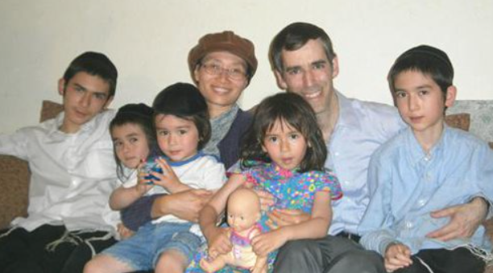

To curb intermarriage, we need young Jews to identify with a Judaism that is relevant and meaningful.

But if Judaism is more than just a tradition, it is built on the revelation at Sinai when G-d gave the Jewish people His Torah, the Divine instruction manual for living, then the ramifications are vastly different. It’s not something I can blithely ignore. They’re commandments; not suggestions. And included in the Torah is the prohibition against intermarriage.

When you identify as a cultural Jew, seeking diversity in your relationship may be appealing. When you identify as a religious Jew, the boundaries are more clearly defined.

So, if we want to curb intermarriage, we need to get young Jews to identify with Judaism as a religion that is [relevant and meaningful](http://www.aish.com/jw/s/10-Things-to-Love-about-Being-Jewish.html), rather than simply as a culture.

**Discovering the Relevance of Judaism**

I believe interdating is a symptom of a problem, namely, Jewish ignorance. My interdating journey forced me to dive into learning anew, unlearn what I believed Jewish religion was, and relearn it with depth and authenticity that fundamentally changed my identity as a Jew.

I believe a big part of Jewish education today must consist of *unlearning*what we assume Judaism is all about. Is Judaism about refraining from eating pork because of habit or tradition, or is it about observing the kosher laws because that’s one of G-d’s ways of ensuring we remain a holy nation? Is Judaism about cultivating a sense of humor, or is it about cultivating a relationship with the Creator?

In short, we need to distinguish between authentic Torah Judaism and its myriad cultural echos.

Only then can we appreciate what it truly means to be Jewish.

*Reprinted from the August 12, 2022 website of aish.com*

**Bus Crash Victim’s Life Saved by Tzitzis**

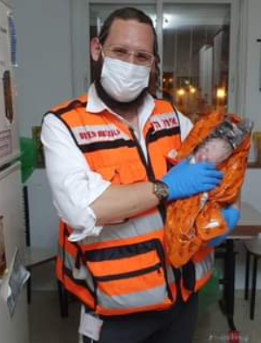

**Recent hoto of Sholom Klein during the Covid 19 pandemic**

Shalom Klein, a United Hatzalah EMT, was standing at the bus stop on Shamgar Street on Thursday night (August 11th) with his wife and seven-month-old daughter when the now infamous Egged bus careened out of control and smashed into the bus stop. Shalom quickly took his family to safety across the street and then rushed back to help the injured.

Arutz Sheva reports the rest of the story: Shalom ran back across the street.

He recounted: “I found a young woman with severe injuries to both of her legs. I took off my tzitzis and I tied them around one of her legs as a tourniquet, stemming the blood flow. Another volunteer EMT from United Hatzalah arrived and tied a tourniquet on her other leg.”

Shalom was later in touch with one of the young woman’s family members. “The woman’s relative told me that she was beginning to recover and the doctors attributed the fact that she was alive to the tourniquets that were put on her legs.

“I never thought my tzitzis would save someone’s life, but they did on Thursday. I am glad that my family is safe, it was an absolute miracle that we weren’t hurt ourselves. The bus careened into the people gathered at the bus stop and it hit people right and left. I believe that I was spared so that I could save this young woman’s life. I was in the right place at the right time to help. I used what I had on me and I improvised just like we are taught in training. Today that lesson saved a life.”

*Reprinted from the August 14, 2022 website of Matzav.com*

**Rav Avigdor Miller on**

**Do I Practice What I Preach**



**QUESTION: Is there a difference between the advice that you give us and what you tell yourself? I guess what I mean is, do you practice what you preach?**

**ANSWER:** Let me explain something to you, an important principle. When I speak to you, I wouldn’t waste my time just for you alone. It’s in the hope that I’m hearing it as well. Yes, that’s the purpose. Agav urcha, I’m letting you listen in as well. But I’m listening too and there’s no question that a speaker becomes influenced by his words.

Rav Yisroel Salanter once asked, “How can one judge the benefit of a mussar schmooze?” And he said, “Even if as a result of his talk only one person davened a better mincha, it was worthwhile. And,” Rav Yisroel continued, “even if that one person who davened a better mincha is the speaker himself, it’s still worthwhile.”

A better mincha—any ruchniyus—is a very big achievement. So therefore whatever you can do for yourself, whether you’re learning alone or teaching others, make sure that you’re listening along as well. You’re listening too and you’re having a benefit. Something rubs off on you. Lo yimaleit! It’s impossible otherwise. Unless you’re epes a ramai gadol. Unless you’re a complete fraud. But an ordinary person, when he talks, he’s listening too.

*Reprinted from the July 26, 2022 emil of Toras Avigdor (Tape E-260, February 2001)*

**The Importance of Faithfully**

**Observing Even those “Simple” Mitzvot**

**From the Talks of the Lubavitcher Rebbe**

**Rabbi Menachem Mendel Schneerson, Zt”l**

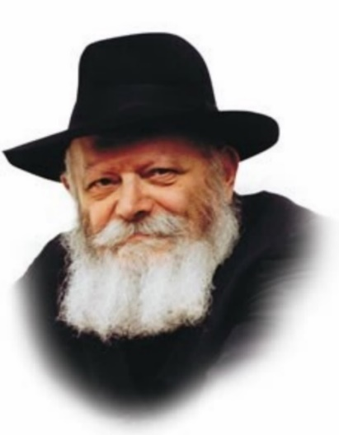

This week's Torah portion opens with an unusual expression: "Eikev ("if" or "because") you listen to these laws..." Instead of the more common word "im" to denote "if," the Torah uses the word "eikev," which means "heel."

According to the Torah commentator, Rashi, eikev alludes to the "simple mitzvot usually trampled underfoot" -- those mitzvot whose importance is sometimes denigrated.

Rashi's explanation is based on a Midrash which states: "These are the simple commandments that people are not always careful to keep; they toss them under their heels."

The Midrash is not referring to a person who considers these mitzvot to be trivial, G-d forbid, or who scorns them intentionally. Rather, the Midrash refers to a Jew who accepts that these mitzvot must be observed and who endeavors to keep them, yet keeps postponing their observance until they are "tossed under the heel."

Such a person is likely to divide G-d's commandments into categories, according to what he perceives as importance.

**Those Who Would Leave the**

**“Simplest” Mitzvot for the Last**

To him, the "important" mitzvot are the "head" and must take priority. "Let me first observe the 'important' mitzvot perfectly ," he says "then I'll start with the others." The simplest mitzvot are left for last. According to this way of thinking, the Jew does not demand of himself a level of conduct that is "within the letter of the law" until he considers himself to have mastered the "important" mitzvot.

What is the consequence of such an outlook? When this person is asked to love every single Jew -- including those he does not know personally -- he replies, "How can you ask that of me? It's hard for me to love people I do know! How can you expect me to extend it to Jews I've never met?"

When pressed to observe mitzvot even more scrupulously than is required he replies, "No! There's got to be a certain sequence in observing mitzvot. Demanding that I do more than the basics is like asking me to walk in the street barefoot while wearing a beautiful tie around my neck! You've got to start at the beginning and work your way up."

**Nothing But the Counsel of the Evil Inclination**

While these arguments may sound logical at face value, they are nothing but the counsel of the evil inclination.

In truth, the foundation of a Jew's G-dly service is his faith; it is predicated on the acceptance of the yoke of heaven, not on intellectual arguments or rationalizations.

The function of the mitzvot is to connect us to G-d. Every mitzva that a Jew observes strengthens his bond with G-d, regardless of whether it is an "important" commandment or a "simple" one, i.e., related to the "head" or to the "heel."

If any mitzva allows us to draw nearer to G-d and unite with Him, why not do it immediately?

*Reprinted from the Parshat Eikev 1997/5757 (Issue #482) edition of L’Chaim Weekly, a publication of the Lubavitch Youth Organization in Brooklyn, NY. Adapted from Likutei Sichot, Volume 19.*

**Rabbi Berel Wein on**

**Parshat Ekev 5782**

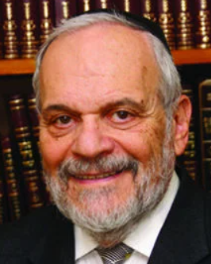

Moshe’s discourse to the children of Israel at the end of his life continues in this week’s parsha. I think that it has to be said that Moshe presents a “fair and balanced” review of the events that have befallen Israel during its desert sojourn. The good and the bad, the exalted and the petty are all recorded for us in his words. And his view of the future of his beloved people is also a balanced mixture of woeful warnings and of great reward, of unlimited opportunity and of crushing defeats.

As always, he is forced to leave the choice of behavior and direction to the people of Israel themselves but he attempts surely to guide their choices in the right direction through his words and predictions. This is perhaps the greatest quality of a leader – the ability to clearly outline significant choices in life and society and give guidance to one’s people to make wise and beneficial decisions.

Leaders who portray only one side of the coin, the bright one– who promise only utopian lower taxes and yet increased welfare programs, peace without sacrifice and social systems of equality and blind justice that do not take into account the realities of human nature – only encourage inevitable disappointment, cynicism and apathy in their people and constituents.

On the other hand, leaders who govern by dire threats, terrible predictions, emphasizing all society’s ills and generating only drabness and a bleak view of the future, destroy human initiative in a fog of pessimism.

Moshe, the paradigm of the great and wise leader presents, throughout his discourse here in the book of Dvarim, both sides of the coin.

Unfortunately, over the ages, the Jews have not always chosen wisely. People hear what they wish to hear no matter what the speaker really says. We are prone to misquote, misunderstand, repeat phrases out of context and generally ignore what we do not wish to hear and understand.

Moshe’s attempt to portray the great achievements of the desert - and especially of Sinai - and balance them with the reminders of the tragedies and wars that also mark Israel’s journey through the desert, had only limited influence on the people. Our sages teach us that the Jewish people simply did not believe Moshe’s dire predictions would ever really occur.

G-d simply had too much invested in the Jewish people. It was a forerunner of our modern “too big to fail” philosophy regarding otherwise corrupt financial institutions.  So Moshe’s darker side of the coin was never really believed by the Jewish people.

They heard only the good – what they wanted to hear – and ignored the rest. There are many Jews today that unfortunately listen to the opposite strains of Jewish life. They despair of our future and our wonderful state. They also only hear what they wish to hear, fueled by a biased and ignorant media and narrow-minded intellectuals. They see no grand future for Israel, the people, the state and the land. A well considered study of Moshe’s words and his realistic and balanced message would certainly be in order.

Shabat shalom.

*Reprinted from the current website of rabbiwein.com*

**The Torah’s Take on the Constitutionality of Abortion**

**By Daniel Keren**

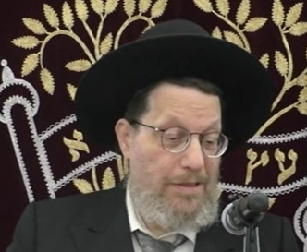

**Rabbi Dovid Ribiat**

One of the recent featured speakers at the Flatbush July 4th Hakhel Yarchei Kallah Event was Rabbi Dovid Ribiat, author of the monumental series of seforim (books) titled “The 39 Melachas.” The topic of his halachic discourse was Contemporary Hilchos Shabbos. Actually, the first question, Rabbi Ribiat addressed was not a Shabbos shailah (question.)

Rabbi Ribiat discussed a major political issue that has major significance for our community and we should be concerned as to what the Torah says about this issue. There is a lot of confusion about this issue (the legality of abortion, the deliberate termination of a human pregnancy.)

**The Recent U.S. Supreme Court Decision Overturning Roe vs. Wade**

Rabbi Ribiat was specifically referring to the recent U.S. Supreme Court 6-3 decision last month (June 22nd) in the Dobbs verse Jackson Women’s Health Organization case that overturned the earlier 1973 Supreme Court decision almost 50 years ago which had at that time declared that women had a constitutional right to abort or end their pregnancy before the fetus is born.

[As a result of that original Supreme Court decision in Roe vs. Wade, according to the Guttmacher Institute, a leading research and policy organization located in Manhattan, more than 60 million fetuses were aborted since that court decision.]

Basically, the Supreme Court decision overturning Roe vs. Wade has declared that there is no constitutional right for a woman to have an abortion and that it is up to the individual states to determine whether or not abortion should be legal or illegal in their states.

Rabbi Ribiat declared that abortion is an issur (forbidden). But what is the nature of this issur? The question in the secular world is if the unborn child is a human being and subject to all of the laws pertaining to a human being. Or is it not a human being? And to what point does it remain not a human being and at what point during the pregnancy does it become a human being.

Rabbi Ribiat explained that although we have to respect the importance of the Supreme Court (and other important governmental agencies), we as Torah observant Yidden still have to analyze the logic of its decision. What is the way that we should be try to understand this decision?

**Recognizing that Abortions is Forbidden to Jews**

One of the reasons why it is important for us to discuss this Supreme Court decision is because it and a host of other decisions relate not just to Yidden. We recognize that abortions is forbidden to Jews. But what is the status of abortion to non-Jews.

In the Torah, it is not a question of whether or not abortion is constitutional right or a state right, the Gemora (Babylonian Talmud) in Mesechta Sanhendrin is quite clear that abortion is Shefichas Damim (bloodshed or murder).

Rabbi Ribiat told the July 4th Hakhel audience that there are many times when we as Shomer Torah mitzvah observant Jews have to be concerned when the courts make decisions or governmental bodies pass a law that might not adversely harm non-Jews but would have a very adverse effect on us as Yidden. For example, let us say that the EPA (Environmental Protection Agency) or the FDA (Federal Drug Administration) would release a regulation that all bread must have a certain ingredient because let’s say a certain concern regarding global warming.

However, this ingredient just happens to be non-kosher. This would not be a problem for non-Jews or even secular Jews. But for us as Shomer Torah mitzvah Jews, this is a very serious problem.

**The Type of Question that Could Negatively Affect Jews**

Similarly let us consider the danger of a law that might be passed requiring certain businesses such as a pharmacy to be opened every day of the week, including Shabbos. This is the type of question that would negatively affect us as Jews and not harm the non-Jewish communities around us.

Returning to the subject of the permissibility of abortions, Rabbi Ribiat said that non-Jews are also forbidden to perform abortions. The Gemora is referring to an adam bi’adam, a human being residing within a human being (a fetus.) This issur for abortions is one of the seven mitzvahs that a Bnei Noach (non-Jew) is obligated to observe.

Those proponents of abortion use the euphemism of calling their support as being “pro-choice” because they want to hide the fact that what they are advocating is simply Shefichas Damim according to the Torah. Rav Moshe Feinstein, zt”l, brings proof that his shedding of the blood of a fetus is prohibited whether or not the baby that is being carried in the mother’s womb is Jewish or not.

According to Rav Moshe even if the mother discovers that the baby she is carrying has serious birth defects such as Tay Sachs Disease, it is forbidden to carry out an abortion even though such a birth would constitute a major burden on the mother.

**An Exception when Judaism Permits Abortions**

On the other hand, if the pregnancy is dangerous for the mother to carry to term and it would result in the death of the mother, according to Torah law, the pregnancy should be terminated even though this would result in the death of the fetus in order to save the mother’s life. The fetus, even though it is not purposely trying to kill his mother, is nevertheless considered by the Torah to be a rodaif, a pursuer who is endangering a human life and to whom it is permitted to kill in order to save the life of the mother.

Rabbi Ribiat noted that other religions, notably Catholicism disagree with the Torah position and forbid that the aborting the fetus even though that would result in the death of the mother.

As Jews, we have to be aware that there are two sides to the question of abortion. The extreme position of anti-abortionists to prohibit all types of abortion is not something that we as Torah loyal Jews could accept when it comes to saving the life of the mother.

Rabbi Ribiat declared that he wanted to make a point concerning the secular or liberal view. He does not believe that they are coming to their position on abortion as a result of a true philosophy. It is not that they are being respectful of the constitutional rights of others.

**Abortion Supporters Have a Rather Degraded Value of Human Life**

Those abortion supporters have in their mind a rather degraded value of human life. For us as Jews, we cannot accept their position. We have to realize that these abortion [pro-choice] supporters are not just prepared to abort and kill their own babies. What is to stop them from deciding that abortion should be mandatory for others who don’t want to abort their children.

Maybe they will pass a law that would mandate the abortion of other groups and classes that these pro-choice advocates deem to be a threat to their [desirable] society because they are having “too” many children. In their eyes, the fetus is not a human life. And that is the logical conclusion of such an immoral philosophy denying the sanctity of the value of the life of the unborn baby. If they are allowed to kill their baby, what is to stop them from legislating the right to abort and kill your baby. We see that this has already been carried out brutally in Communist China.

Rabbi Rebait declared that we know that according to the Torah, the birth of more babies in the fulfillment of the first mitzvah of peruvu (being fruitful) can only bring blessing to the world if the children are raised in a proper moralistic matter.

**Insights into the Mitzvah**

**Of Birkat Ha’mazon**

In this week’s Parashah, (8:10) we are taught the Mitzvah of Birkat Ha’mazon / “Bentching” after eating. R’ Moshe Yechiel Epstein z”l (1889-1971; Ozharover Rebbe in New York and Tel Aviv) writes:

“A blessing, in general, and Birkat Ha’mazon, in particular, involves both accepting the yoke of Heaven as well as praying for G-d’s continued beneficence. He explains: Because reciting a blessing involves accepting the yoke of Heaven, our Sages (Tosefta, end of Berachot) describe reciting blessings as “performing Mitzvot.”

Indeed, the word “Mitzvah” means “something we are commanded to do.” When one does something he is commanded to do, he, in effect, accepts upon himself the yoke of the one who commanded him to do that thing–in this case, Hashem.

He continues: When Pharaoh commanded Bnei Yisrael to leave Egypt, he said (Shmot 12:32), “You shall bless me.” The Aramaic translation Onkelos renders this: “You shall pray for me.”

Rashi z”l, as well, explains: “Pharaoh was a firstborn, and he wanted Moshe to pray that he not die in the plague.” Thus, we find that the term the plague.” Indeed, the fact that He promised us the Land was our guarantee that the redemption would indeed come. (Haggadah Shel Pesach Shirat Ha’geulah)

*Reprinted from the Parshast Eikev 5782 email of R’ Yedidye Hirtenfeld’s email of the parsha sheet whY I Matter for the Young Israel of Midwood in Brooklyn.*